DETAILED RESUME
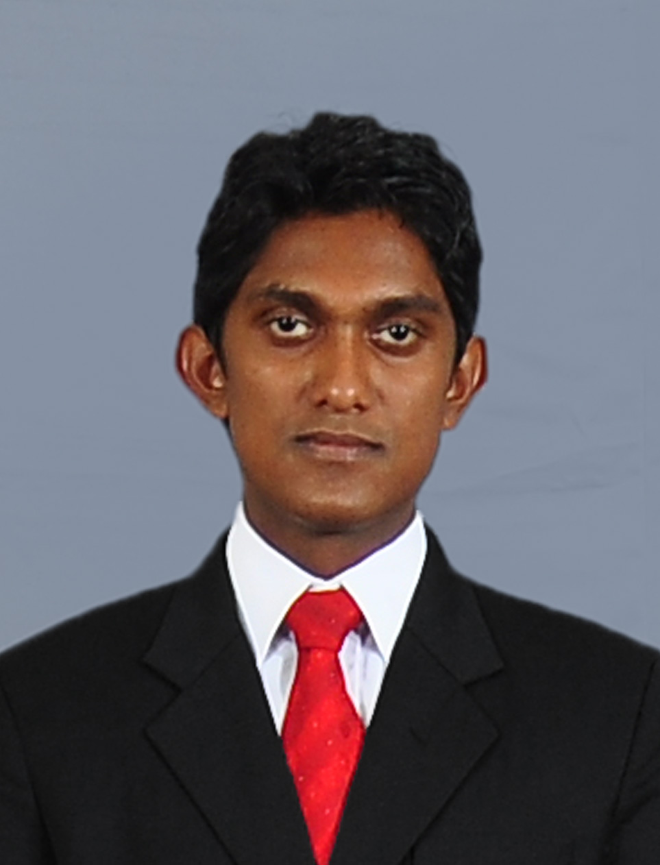
MISSION
Exposure myself to challenging business environment with substantial competencies of knowledge, skills & attitudes and contributing to the success of the organization’s business & operation strategies and moreover formulate innovative strategies in field of business & operation to enhance the efficiency and effectiveness of the field.

PERSONAL PREFERENCES
- Integrity
- Punctuality
- Team-spirit
- Strategic decision-making
- Flexibility
- Think win – win
- Begin with the End in mind

Of
W.S.P. Fernando
118/22, Lower Indibadda,
Moratuwa.
Tel: 071-0633647
E-mail: shanaka.piumal@gmail.com

ACADEMIC QUALIFICATIONS

I have completed B.A (special) Degree in Economics with a Second Class Upper at Sabaragamuwa University of Sri Lanka (2009/2010).
Major subject: Economics
Minor subject: Computer Studies

EDUCATIONAL QUALIFICATIONS

G.C.E. Advanced Level Examination – 2009

Subjects Grade

Economics - B

Accounting - B

Business Studies - A

General English - C

Common General Test - 68

Z-score - 1.4477

G.C.E. Ordinary Level Examination – 2006

Subjects Grade

English - A

Sinhala - A

Buddhist - A

Social Studies - A
Science & Technology - B

Mathematics - C

Commerce - S
Music - S

ENGLISH LANGUAGE PROFICIENCY

- I have successfully completed one year Diploma in English Course at Sabaragamuwa University of Sri Lanka.
- I have successfully passed the first ever University Test of English Language (UTEL) conducted by the Ministry of Higher Education in 2013.
- I have attended a Certificate Course in Spoken English.

COMPUTER LITERACY

- I have successfully passed the first ever University Competency Test of Information Technology (UCTIT) conducted by the Ministry of Higher Education in 2013.
- I followed Computer Studies as the Minor subject during the degree program, which included System Designing, Database Handling, and Advanced Web Designing (PHP) etc.
- I’m capable in designing and handling computerized systems/projects using different platforms such as VB, PHP and MySQL techniques.
- I have followed a computer course under the guidance of ministry of education in western province that included Microsoft office package.
- I have adequate knowledge about internet and E mail.

LEADERSHIP ACTIVITIES

- I was the Head Prefect of the School in 2008.
- I was the President of School's English Literature Association in 2006.
- I was the Vice president of the School's Buddhist Association.
- I was a Member of School's Drama Society.
- I was the Captain of School's under 14 Cricket Team in 2006.

WORKING EXPERIENCE

- I have worked as a Data Enumerator at International Labor Organization (ILO) for the project named Decent Work on Tea Plantations in Sri Lanka.
- I have worked at Union Assurance PLC as an Insurance Advisor.

OTHER QUALIFICATIONS

- I have obtained a Driving License for Light Vehicle Category including Motor Bikes.

PERSONAL INFORMATION

Name in Full : Weerahannadige Shanaka Piumal Fernando.

Address : 118/22, Lower Indibadda, Moratuwa.

Contact Numbers : 071-0633647

E mail Address : shanaka.piumal@gmail.com

NIC No : 910281950 V

Date of Birth : 28th of January 1991 (24 Years of age)

Civil Status : Single

Gender : Male

Nationality : Sri Lankan

Schools Attended : Wp/Pill/Methodist High School Puwakkaramba, Moratuwa.

NON-RELATED REFEREES

Dr. S.J.M.N.G. Samarakoon  Senior Lecturer (Gr. I)  Department of Economics and Statistics,  Faculty of Social Sciences & Languages,  Sabaragamuwa University of Sri Lanka,  Belihuloya,  70140,  Sri Lanka.  Telephone: +94(0)45 – 2280048 / 0716826652 | Mr. R.M. Nevil B. Rathnayake  Senior Lecturer (Gr. II)  Computer Center,  Faculty of Social Sciences & Languages,  Sabaragamuwa University of Sri Lanka,  Belihuloya,  70140,  Sri Lanka.  Telephone: 0712408241

I do hereby declare that particulars furnished by me are true and correct to the best of my knowledge.


27/10/2015 ….……………
Date Signature
(W.S.P. Fernando)

